FUZZ FACE
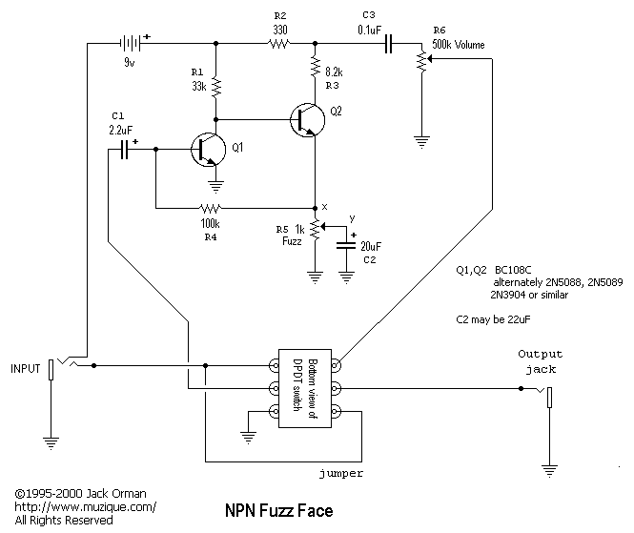
http://www.google.com.mx/imgres?imgurl=http://img842.imageshack.us/img842/3811/fuzzface3.gif&imgrefurl=http://www.diystompboxes.com/smfforum/index.php?topic%3D98131.0&h=559&w=665&sz=8&tbnid=Jc-GVzJqVhrG6M:&tbnh=90&tbnw=107&zoom=1&usg=__BwcKd05-R_dlgaSW2yqxOTuHrqU=&docid=MrMalfdVZQe7dM&sa=X&ei=05x5Ub6NE-qg2QXCkYDwCA&ved=0CDAQ9QEwAA&dur=240
boost
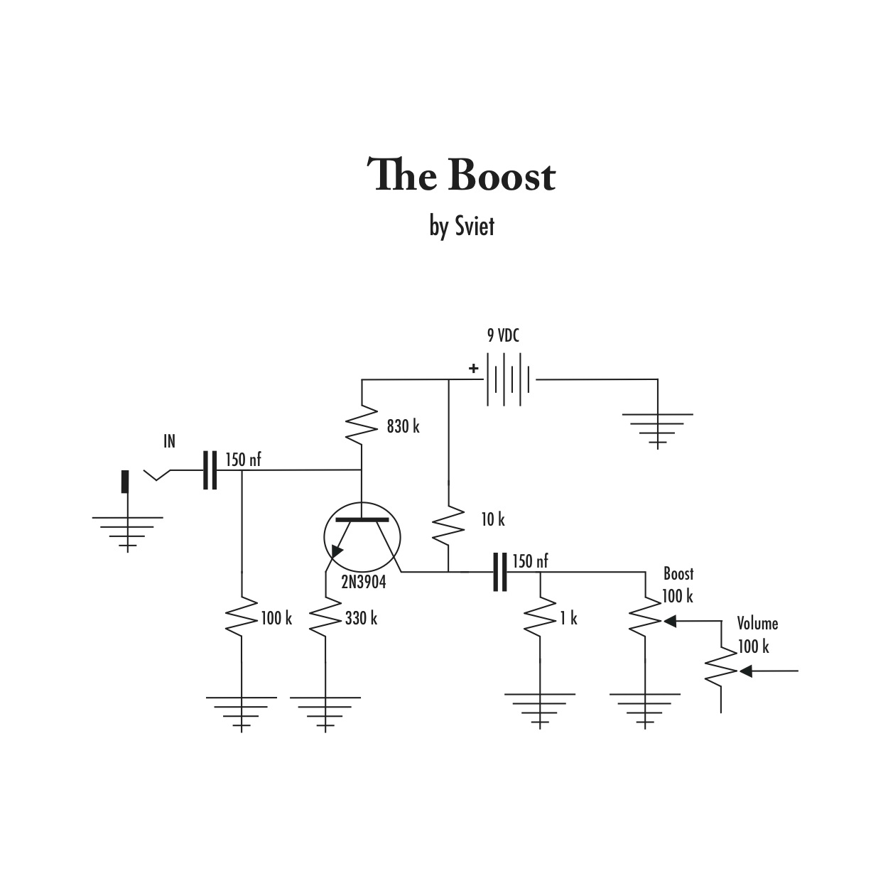
http://www.taringa.net/posts/hazlo-tu-mismo/8517806/Pedal-efecto-para-Guitarra---The-Boost.html

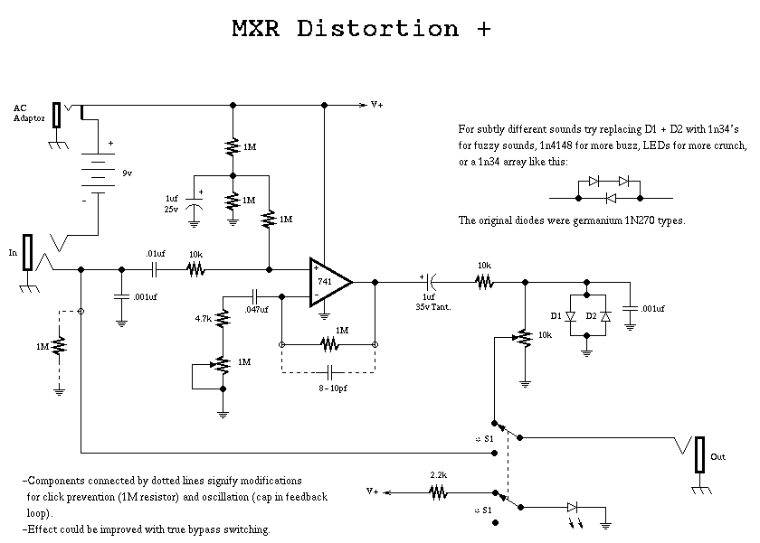
http://www.pisotones.com/Distorsion+/Dist+.htm

